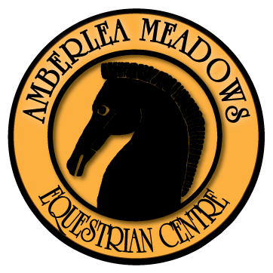
Page 1 of 2

Please print this form and fill out complete with
signature then scan and email to:
admin@amberleameadows.com

2023 REGISTRATION FORM
Student or, name of Child Registering _______________________ has ridden for __________ years.
Student has had riding instruction for ________ years. Age of Student: _________________________________
Brief summary of student’s previous riding experience.
____________________________________________________________________________________________________________________________________________________________________________________________________________________________________________________________

Essential Equipment – Students are required to wear an ASTM Riding Helmet and boots with a riding heel.

Beginner Camp- With an emphasis on the fun side of riding. Learning the basics both on and off of the horse.
⃝ Date: August 14-16 $400.00 + GST (20.00) $420.00

Novice Intermediate Camp- For the rider who wishes to improve their dressage riding skills /& learn basic jumping skills.
⃝ Date: Aug 21-25 $600.00 + GST (30.00) $630.00

Please note that space is limited, so please register early!
Name _________________________________________
Address _________________________________________
City ________________ Prov. ______________ Postal Code ______________
Telephone: (daytime)_________________________ (cell)_______________(other)_______________
A.H.C. # ____________________________

Page 2 of 2

Family Doctor Name and Phone # ______________________________________________
Any allergies/ medical history we should be aware of?_______________________________________________________________________________________________________________________________________________________________________________________________________________________________________________________________________________

This Document will affect your legal rights and liabilities, Please Read Carefully

I acknowledge that the sport of horses is a risk sport and that I am participating at my own risk and in full knowledge of the hazard which are inherent in this sport. I further acknowledge the inherent risks in riding and working around horses, which risks include bodily injury to both horse and rider which can result from normal use, competition, or schooling. It is hereby also understood that no helmet or protective equipment can protect against all foreseeable injury.

In consideration of being allowed to participate in the Amberlea Meadows 2020 Summer Camp, I hereby assume all risk and I hereby release and absolve Amberlea Stables Ltd., their directors, officers, employees, volunteers, and representatives, and their personal representatives, from all responsibility, liability or claims of any nature and kind which I may have arising from my participation in this activity, including but not limited to bodily injury or death to myself or my horse(s) and damage to property arising from any cause whatsoever, including the negligence of one or more of the individuals and organizations referred to herein.

I hereby declare that in signing this document, that I have read and fully understand and agree to the terms and conditions stated herein and that it is binding upon my executors, heirs and assigns.

I acknowledge as parent/ legal guardian of ________________________ that I have read and fully understand and agree to the terms and conditions stated herein on behalf of the above named child and myself.

Parent/ Legal Guardian______________________________Date___________________2023

